**Project NAME: V-Score**

**Problem Statement:**

The problem here would be the ability for lecturers to create and maintain their scoreboard when it comes torecording their quiz scores. Normally, they would have to create an excel sheet to store the data and scores and they would have to manually count the overall score or various other calculation such as score improvements across the weeks. Besides, it would be hard for the user to keep track of the weekly scoreboard and to maintain the overall leader board as there is too much visual on the screen. Besides, in a semester, there is 15 weeks in a semester technically. Thus, storing 15 weeks’ worth of scores for multiple students is arduous and tiring. The maintenance is going to be hard for those 15 weeks. ­­Besides, it is hard to delete columns or choose certain columns to view as there is too many columns which makes it confusing in the long run. Thus, this web app I proposed aim to solve these grievances. I plan to automate the calculation process and to better divide and organise the weekly scores easily. Thus, the only thing the lecturer or user has to do is to input the data such as scores, questions answered correctly and players or students name. Besides, the user can choose to show which columns they want and hide the columns they do not want. Automated calculation would be for the improver score that compares previous week scores against current week scores, improver questions answered that compared previous weeks correct questions against current week correct questions, and rank increase or decrease compared to previous week. Another automated calculation would be the overall rank, scores and questions correct for each students. Users could also produce top results based on their criteria and also generate graphs from it.

**Data preparation/collection**

I plan to collect data from the available and public excel sheet that is provided in the Blackboard. Particularly, I am talking about the excel spreadsheets that from the Kahoots! Scores that is maintained for several weeks already. Thus, giving me exact data and idea and how to process the data in my web app.

**Use cases**

**Company Case Study**

|  |  |
| --- | --- |
| **ID:** | **Lecturer Case Study (LD1)** |
| **Title:** | Process of a lecturer trying to update the scoreboard |
| **Description:** | The goal for lecturer is to insert new scores for week 5 and to update the overall scores and also to select the top 5 ranked overall and to generate a graph to show the five students’ rank throughout week 1 to week 5. |
| **Primary Actor:** | Lecturer |
| **Preconditions:** | 1. The lecturer had created a profile and an account to access the dashboard.  2. The lecturer had already updated scores from week 1 to week 4. |
| **Postconditions:** | 1. The lecturer successfully updated the scoreboard and publishes the result into the main page. |
| **Main  Success Scenario:** | 1. The lecturer logs into their user profile  2. The lecturer can access the lecturer dashboard  3. The lecturer access their scoreboard  4. The lecturer choose from the week drop down and choose week 5 to edit week 5 scoreboard.  5. The lecturer adds in the scores and questions correct for each student for week 5 scoreboard  6. The system updates the ranking of the students for part 5, improver rank, improver scores and improver questions correct in scoreboard for week 5.  7. The lecturer clicks on the overall leaderboard and the leaderboard updates to show the overall scores, question correct and rank from week 1 to 5.  8. The lecturer selects the top 5 ranked students in the top results section and generate a table showing the top 5 students.  9. The lecturer generates a graph that show the ranking graphs of the top 5 students from week 1 to week 5  10. The lecturer publishes scoreboard for week 5, the overall leaderboard and the top 5 ranked including the graoh to the home page which visitors can view. |
| **Extensions:** | 1a. The lecturer cannot log onto his user profile because of wrong username or password  -The system will print out an error message and highlight the input box on which information the lecturer input wrong.  1b. The lecturer did not input their username or password and tries to log on  -The system will print out a message telling the lecturer to write down their relevant information  2a. The lecturer dashboard does not load  -The system will print out a message saying the page could not load and is currently unavailable.  -The system sends the lecturer back to main page  3a. The system cannot load the scoreboard  -The system should reload the page to return to previous state  4-6a. The lecturer wants to add new players or students into the scoreboard.  -The lecturer should click the add players button in the weekly scoreboard section to add new players  4-6b. The lecturer wants to create a new scoreboard with new players.  -The lecturer should click remove all players and their scores and use the edit scoreboard details to add new players  4-6c. The lecturer wants to remove one player  -The lecturer should click the trash button for specific rows to remove that particular player and their scores from the scoreboard.  4-7a. The lecturer wants to search for specific students  -The lecturer should use the search buttons to find specific students records.  4-7b. The lecturer wants to sort the records by ranking  -Click the arrow button in the rank, improver rank, overall rank columns to sort  6a. The improver rank, scores and questions correct is not updated after entering the scores and question correct  -The lecturer should reload the page  6-8a. The lecturer wants to hide some columns like improver questions correct  -The lecturer should click on the display drop down and chose which columns to show and hide by checking the checkbox  8-9a. The lecturer cannot generate the graph  -The system will print out an error message telling the lecturer to choose which top 5 table do the user wants to generate as the graph will be generated according to the table chosen.  10a. The scoreboards and graph published is not shown in the home page  - The system will print out a message saying the page could not load and is currently unavailable. |
| **Frequency of Use:** | Will be used whenever the user wants to insert scores for quiz or other form of tests that requires scoring across 15 weeks in an academic semester. |
| **Status:** | In preproduction stage |
| **Owner:** | Lim Jia Lok |
| **Priority:** | High priority |

**5. Comply and demonstrated appropriate use of features integrated in the web development frameworks. –**

**Bootstrap**

**Grid**

-The grid system is used to placed various elements and to resize properly using xs and md

**Box Modal**

-I will use this pop up for log in page for the lecturer’s dashboard

-It will be used for sign up form as well

**Glyph icons**

-The search icon with the search button

-The trash icon with the delete button

-The + icon with the adding button for adding the players

-The edit icon with the edit button to edit scores and questions correct or change their name

**Accordion/Collapsible**

-This is used to divide several sections into edit scoreboard details, weekly scoreboard, overall leader board and top results and to save space and prevent information overload.

**Input Sizing**

-This used to properly resize the forms and input boxes for mobile view and desktop view

**Pagination**

-This is used in to show 10 records of the students per page in pagination to avoid overloading the page with too much information

**Table**

**-**This is used store the scoreboards and the scores and questions correct can be edited

**AngularJS’s controller**

-To store the students record in a $scope array that will be declared in the controller. Ng-repeat is then used to store the records onto a table. The user can add and delete the records using .push and .splice function in the controller. The scores and questions correct can be edited

-The array used to store the students records will then be filtered using filter function in to filter the student names to bring out specific record to change.

-Using NgTable to hide or show selected columns in a table using checkboxes to set the criteria

**AngularJS’s route and ng-view**

-The various different tables in each section will be created in a separate htmls. It will then be routed into the dashboard html. For the 15 weekly scoreboards, they would be created in separate html files to differentiate each week and then routed into the dashboard in which the week drop down will then perform routing to the specific view based on the specified week scoreboard.

**AngularJS’s custom filter and custom directive**

-The custom directive is used to show the scoreboards in the home page when the lecturer decides to publish the scoreboards.

-The custom filter is used to show and format – or + sign to attach to the numbers in the improver columns to show the increase or decrease in value.

**6. Proposed & brief description of external library(ies) / framework(s) integration**

**Chart.js**

The reason for to use this is to create a line graph to show the progression of the top results based on selected criteria. Besides, it is responsive in both tablet and mobile version.

**Moment.js**

The reason for me to use this is because I wanted to inject a date manipulation ability into my web app. This is to show on the home page of the web app when the scoreboards are posted and the visitors could check which date it was posted to know which time and date in the week the scoreboard belongs to.

**KendoUI**

The reason for me to use this is because it provides advanced UI features and it easily provide any requested view. The UI features that it has provides a more responsive web app. It has an amazing grid usage that allows me to group a grid or table by column which makes it even easier to sort the grid based on information that I want to sort with.

**7. References of external library(ies) / framework(s) / idea integration**

**Chart.js**

I know about this framework as I was searching for the any framework that allows me to generate charts or line graphs. It was recommended in reddit and other blogs with the other being D3.js. I chose this instead because it is more lightweight and easier to use.

**Moment.js**

I know about this framework when I googled any frameworks that can inject date element and can easily customized the format. There were date framework but I used Moment.js because it is the most recommended one.

**KendoUI**

I know about this as I was searching for recommended frameworks to use through Google. I went to the KendoUI website and browse through the demo took for what UI implementation I could use. The inspiration I got to make my tables or grid and also a scheduler comes from those demos. The grid demo especially is useful as I can just drag the column of the grid to sort it by the grid. Effectively giving me a sorting option.

**8. Web app wireframes in both desktop & mobile (portrait & landscape) views**

**Desktop Wireframe**

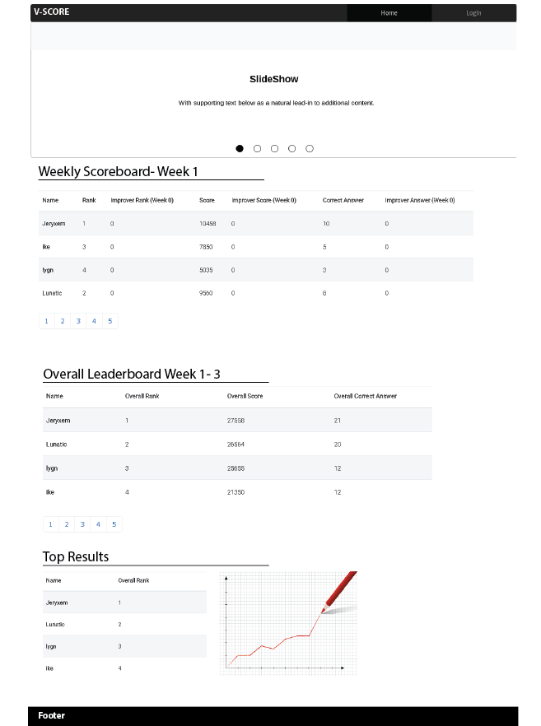

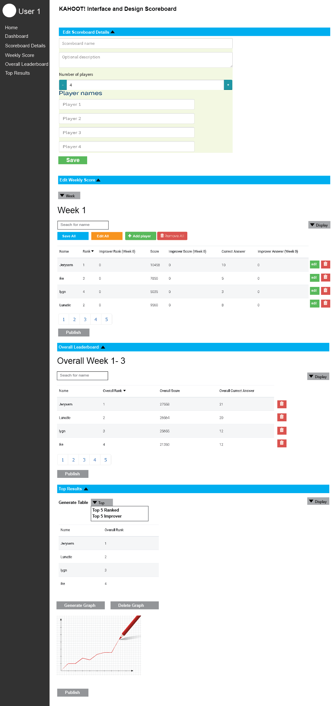

**Mobile Wireframe**

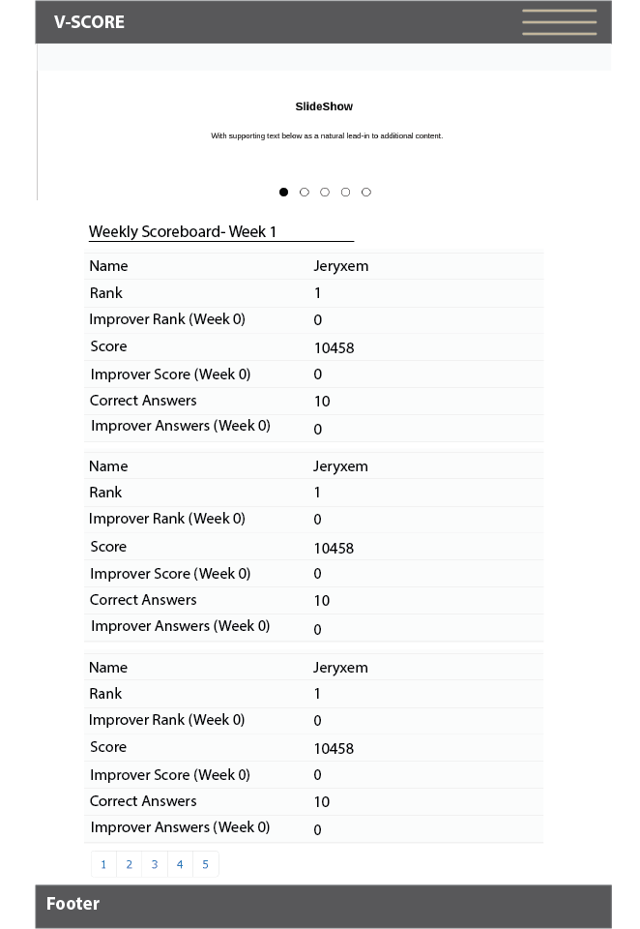

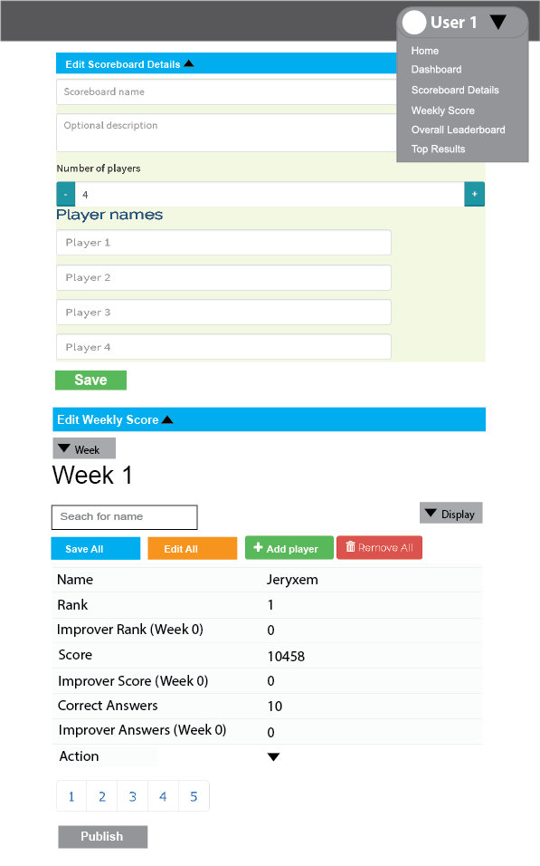

**Mobile Wireframe(Landscape)**

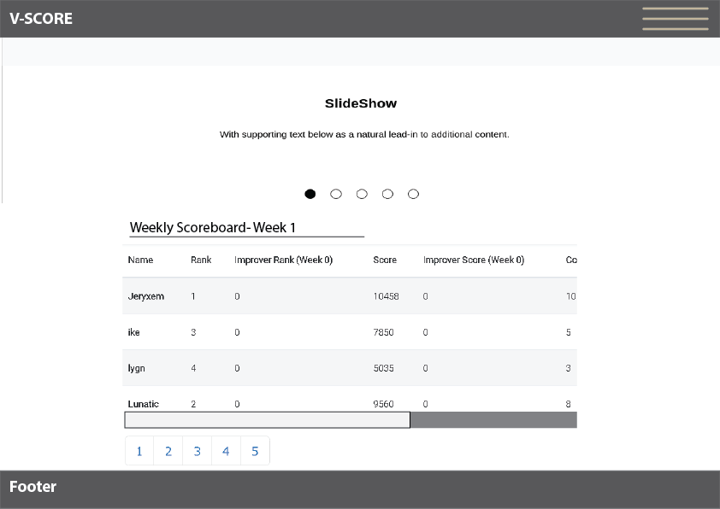

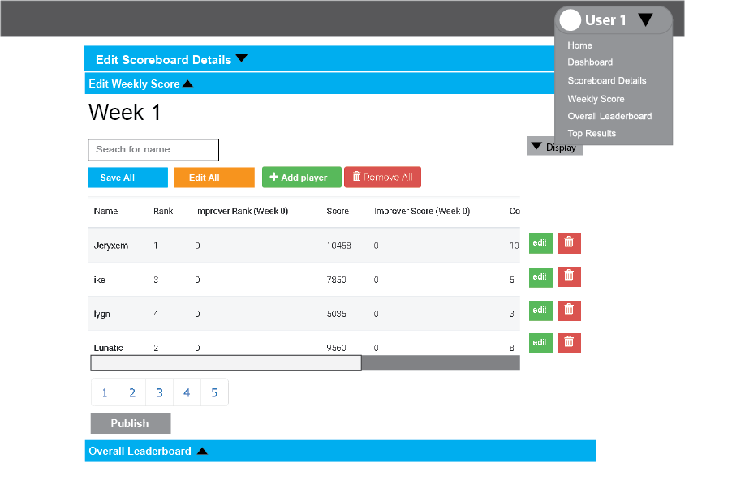

**Note\***

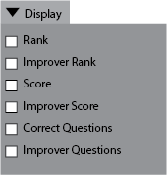

**Used to show and hide columns of the table using Ngtable directives**

**References: https://codepen.io/christianacca/pen/meevep**